Worship Together Music Format

MIDI Pitches

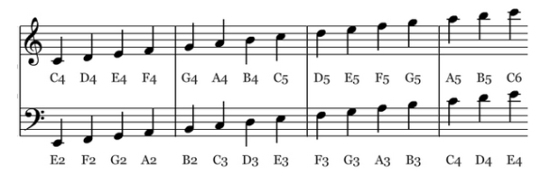

File Names

<page> - <title> - <psalm>

tune - <title>

* 008 - Chide Me, O LORD, No Longer - Psalm 6
* 219 - Come, Thou Long-Expected Jesus
* On This Day Earth Shall Ring

Song Attributes

**title** Chide Me, O LORD, No Longer  
hymnal Cantus Christi  
page 312  
author Aurelius Clemens Prudentius, 348-413

collection Whitefield's Collection, 1757

translator st. 1-2 Theodore Baker, 1894  
translator st. 3 Harriet R. Spaeth, 1875

psalm 19

Tune Attributes

* Bold attributes are required.
* For songs with irregular rhythm, use ‘0 : 4’.
* For notes above the normal voice range, use ‘+’ octave.
* For notes below the normal voice range, use ‘-‘ octave.
* The default fraction is a quarter note.
* Rests have pitch name ‘R’
* Fermata represents a count of additional beats.

tune NE VEUILLES PAS, O SIRE  
metre 7 7 6. 7 7 6  
composer Genevan Psalter, 1542  
harmony Claude Goudimel, 1564; alt.  
**key** Eb  
**rhythm** 0 : 4  
**tempo** 180

Voices

voice soprano E4 to D5  
voice alto A3 to G4  
voice tenor E3 to D4  
voice bass A2 to G3

voice unison E4 to D5

Notes

g#+/32.(1.2)

Pitch

Dotted

Octave (+/-)

Fraction Of Whole

Accidental (#/b)

Fermata (beats)

Measures

soprano c/2 | c c d c | c/2 a/2 b/2 | a g/2 f/2 e  
alto a+/2 | a+ f f f | e/2 d/2 d/2 | c/2 d. a/8 c/2  
tenor c/2 | c a b a | g/2 f/2 f/2 | a c b a/2 g   
bass R/2 | f f b+ f | c/2 d/2 b/2 | f e d/2 c/2